**SOW (Final)**

**CAPSTONE TERM - II**

*COURCE FACILITATOR: MARCOS BITTENCOURT*

|  |  |
| --- | --- |
| NAME | Reg. No |
| Mohamad Althaf | 100757321 |
| Karthik Ashok | 100695894 |
| Vinod Vijayaraghavan | 100772404 |
| Saravanan Balasubramanian | 100699139 |

**RATIONAL STATEMENT**

This project start from the view that it is possible to identify the expressions of customers on different products by making use of Artificial intelligence and computer vision. Our primary focus is for clothing stores because a clothing store is an ideal place for implementing our system.

We are going to build a face recognition systems for expression extraction using computer vision with large sets of data on facial expressions. This will help the management to find the feedback from customers with ease and thereby make them make better decisions which will help them grow.

**KEY METRICS TO BENCHMARK BUSINESS VALUES**

By analyzing the positive and negative attitudes towards a particular category of products using our system,

* Show room managerial could analyze the product selection and refinement using the results of analysis.
* This also helps to understand the ongoing trends of products in the showroom.
* This system will also help the management to understand the demonstration quality of aisle.

**PROBLEM STATEMENT**

Our idea is to develop an application to detect real-time facial expressions using computer vision for clothing showrooms. This system can identify the customers’ attitude towards the products and the arrangement mechanism in the showroom. This helps the businesses to understand the trends and interests of clothes and accessories plus the arrangement priorities of the showroom.

Given a customer and his expression towards the products in the store, an analysis about the feedback of the customers on the products is created using a dashboard. There are three problems that have to be handled during the development of the system: face recognition, expression extraction and creating an analysis based on the feedback of the customers.

**DATA REQUIREMENTS**

Followings are the minimum requirements in dataset to build the model successfully.

1. Grayscale images:

This will be our independent variable that’ll be used to detect the sentiments of faces. These are basically 2-dimentional cropped images of faces. At least 7000 images need to be used in training to get a better model.

1. Facial key features:

This will be our second set of independent features used in our model. These are basically pixel coordinates of facial key feature points. Each image data points should have these key feature points.

1. Sentiment labels:

This will be the dependent/predictive variable in our model. In testing dataset, each grayscale image should have evenly distributed category of these labels to predict and analyze the sentiments of people faces. Followings will be the classes of labels

* Angry
* Disgust
* Fear
* Happy
* Sad
* Surprise
* Neutral

**ASSUMPTIONS, LIMITATIONS AND CONSTRAINTS TO MOVE FORWARD THE SYSTEM**

* The user’s sentiments may not be related to the product. Maybe the customer is just having a bad day and the model will assume customer is not happy with the product.
* On rush days like black Fridays, the system might not be able to keep up because a lot of facial expressions has to be captured and processed in parallel.
* The system requires the clothes to be arranged in separate sections. I.e. if there are different types of clothes in different sections, system won’t be able to predict what sentiment corresponds to which product.
* The system will need a cloud service to run continuously and uninterruptedly. Which is expensive at this point in time.
* Customers may have privacy concerns regarding capturing their sentiments for the purpose of making business more profitable.

**METHODOLOGY**

Step 01: Find the right dataset for training

Step 02: Pre-process the dataset after an exploratory data analysis

Step 03: Create a Convolutional Neural network

Step 04: Train the model with the training set

Step 05: Validate the model with testing set

Step 06: Save the model for the final system

Step 07: Create the web app in cloud with a front end to show the analysis from each camera

Step 08: Use the saved model and test it for real time cameras

Step 09: Test the application for final

Step 10: Deploy the model

Data Collection

Data Pre-processing

Creating a CNN model

Test the model

Validation Failed

Validation Success

Create the Application

Load the model and host the application in cloud

Test the Final system

Deploy the Final system

Test Failed

Test Success

**DEPLOYMENT MODEL**

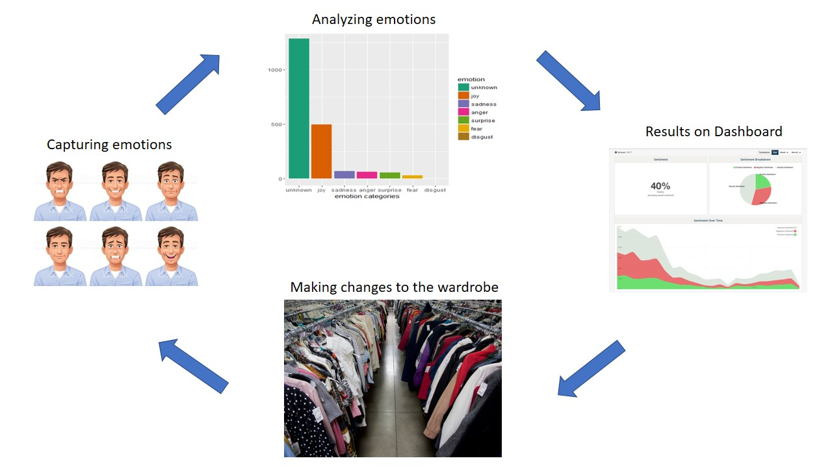

Our system will capture real time video frames and send it to the model for analysis. The analysis results will be visible in the dashboard. Shop owner/ Management can make decisions based on the results and make changes to their clothing sections.

**PROJECT TIMELINE**

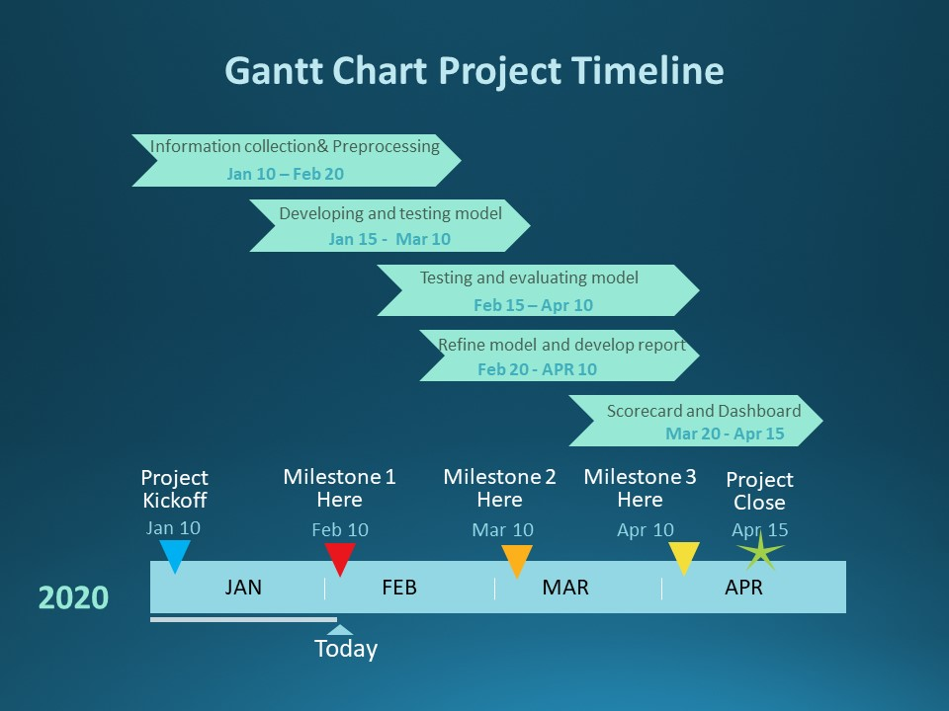

**DATA SET**

To experiment with the recommendation algorithms, we will need data that consists of a images which are labeled with emotion data. The dataset that we have chosen is the Facial Expression Recognition (FED) Dataset from Kaggle. The dataset consists of 48 x 48 pixel images of faces. The images are gray-scaled. The images in the dataset are so aligned in such a way that the face are more or less centered and captures the same amount of distance with rest of the images.

The dataset is labeled with seven categories:

* Angry
* Disgust
* Fear
* Happy
* Sad
* Surprise
* Neutral

The dataset file comprises of three major files, one FED.csv file containing the train and test data and the train.csv and test.csv which are actually split for model training and evaluation. The train.csv files consists of 35,888 entries of two selection of columns, “emotion” and “pixels”. The emotion columns consists of values ranging from 0 to 6, each representing an emotion according to the label codes above. The pixel columns consists of pixel values written in a single string for each of the image.

Requirements to run the code:

* Python
* Jupyter notebook
* Necessary libraries:
* Pandas
* Numpy
* Matplotlob
* Sklearn
* Tensorflow
* Keras
* Opencv2

Kindly find attached the link to my Exploratory Data Analysis Jupiter notebook.

<https://github.com/saravanan21030/RealTimeFacialRecognition>